Measuring the pulse of freedom : An index of economic freedom

INTRODUCTION :

An index of economic freedom measures jurisdictions against each other in terms of parameters such as trade freedom, tax burden, judicial effectiveness, and more.

EMPATHY MAP:

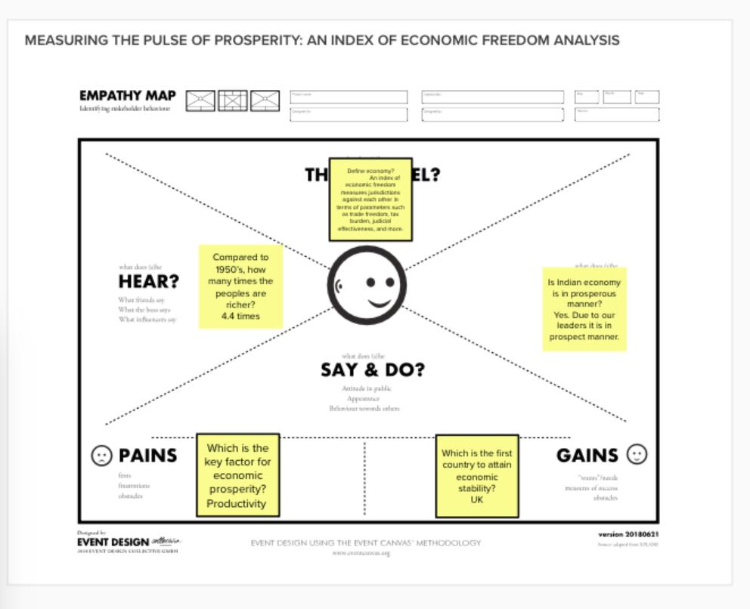

STORY:

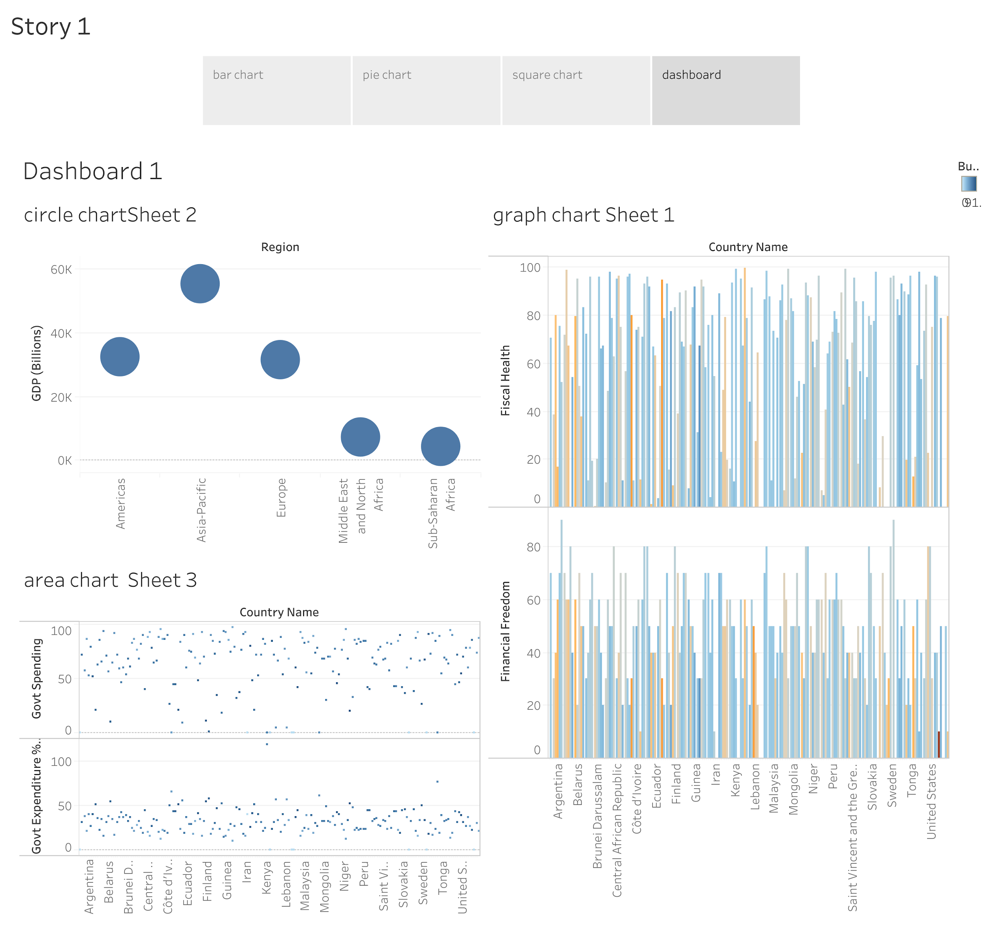

DASHBOARD:

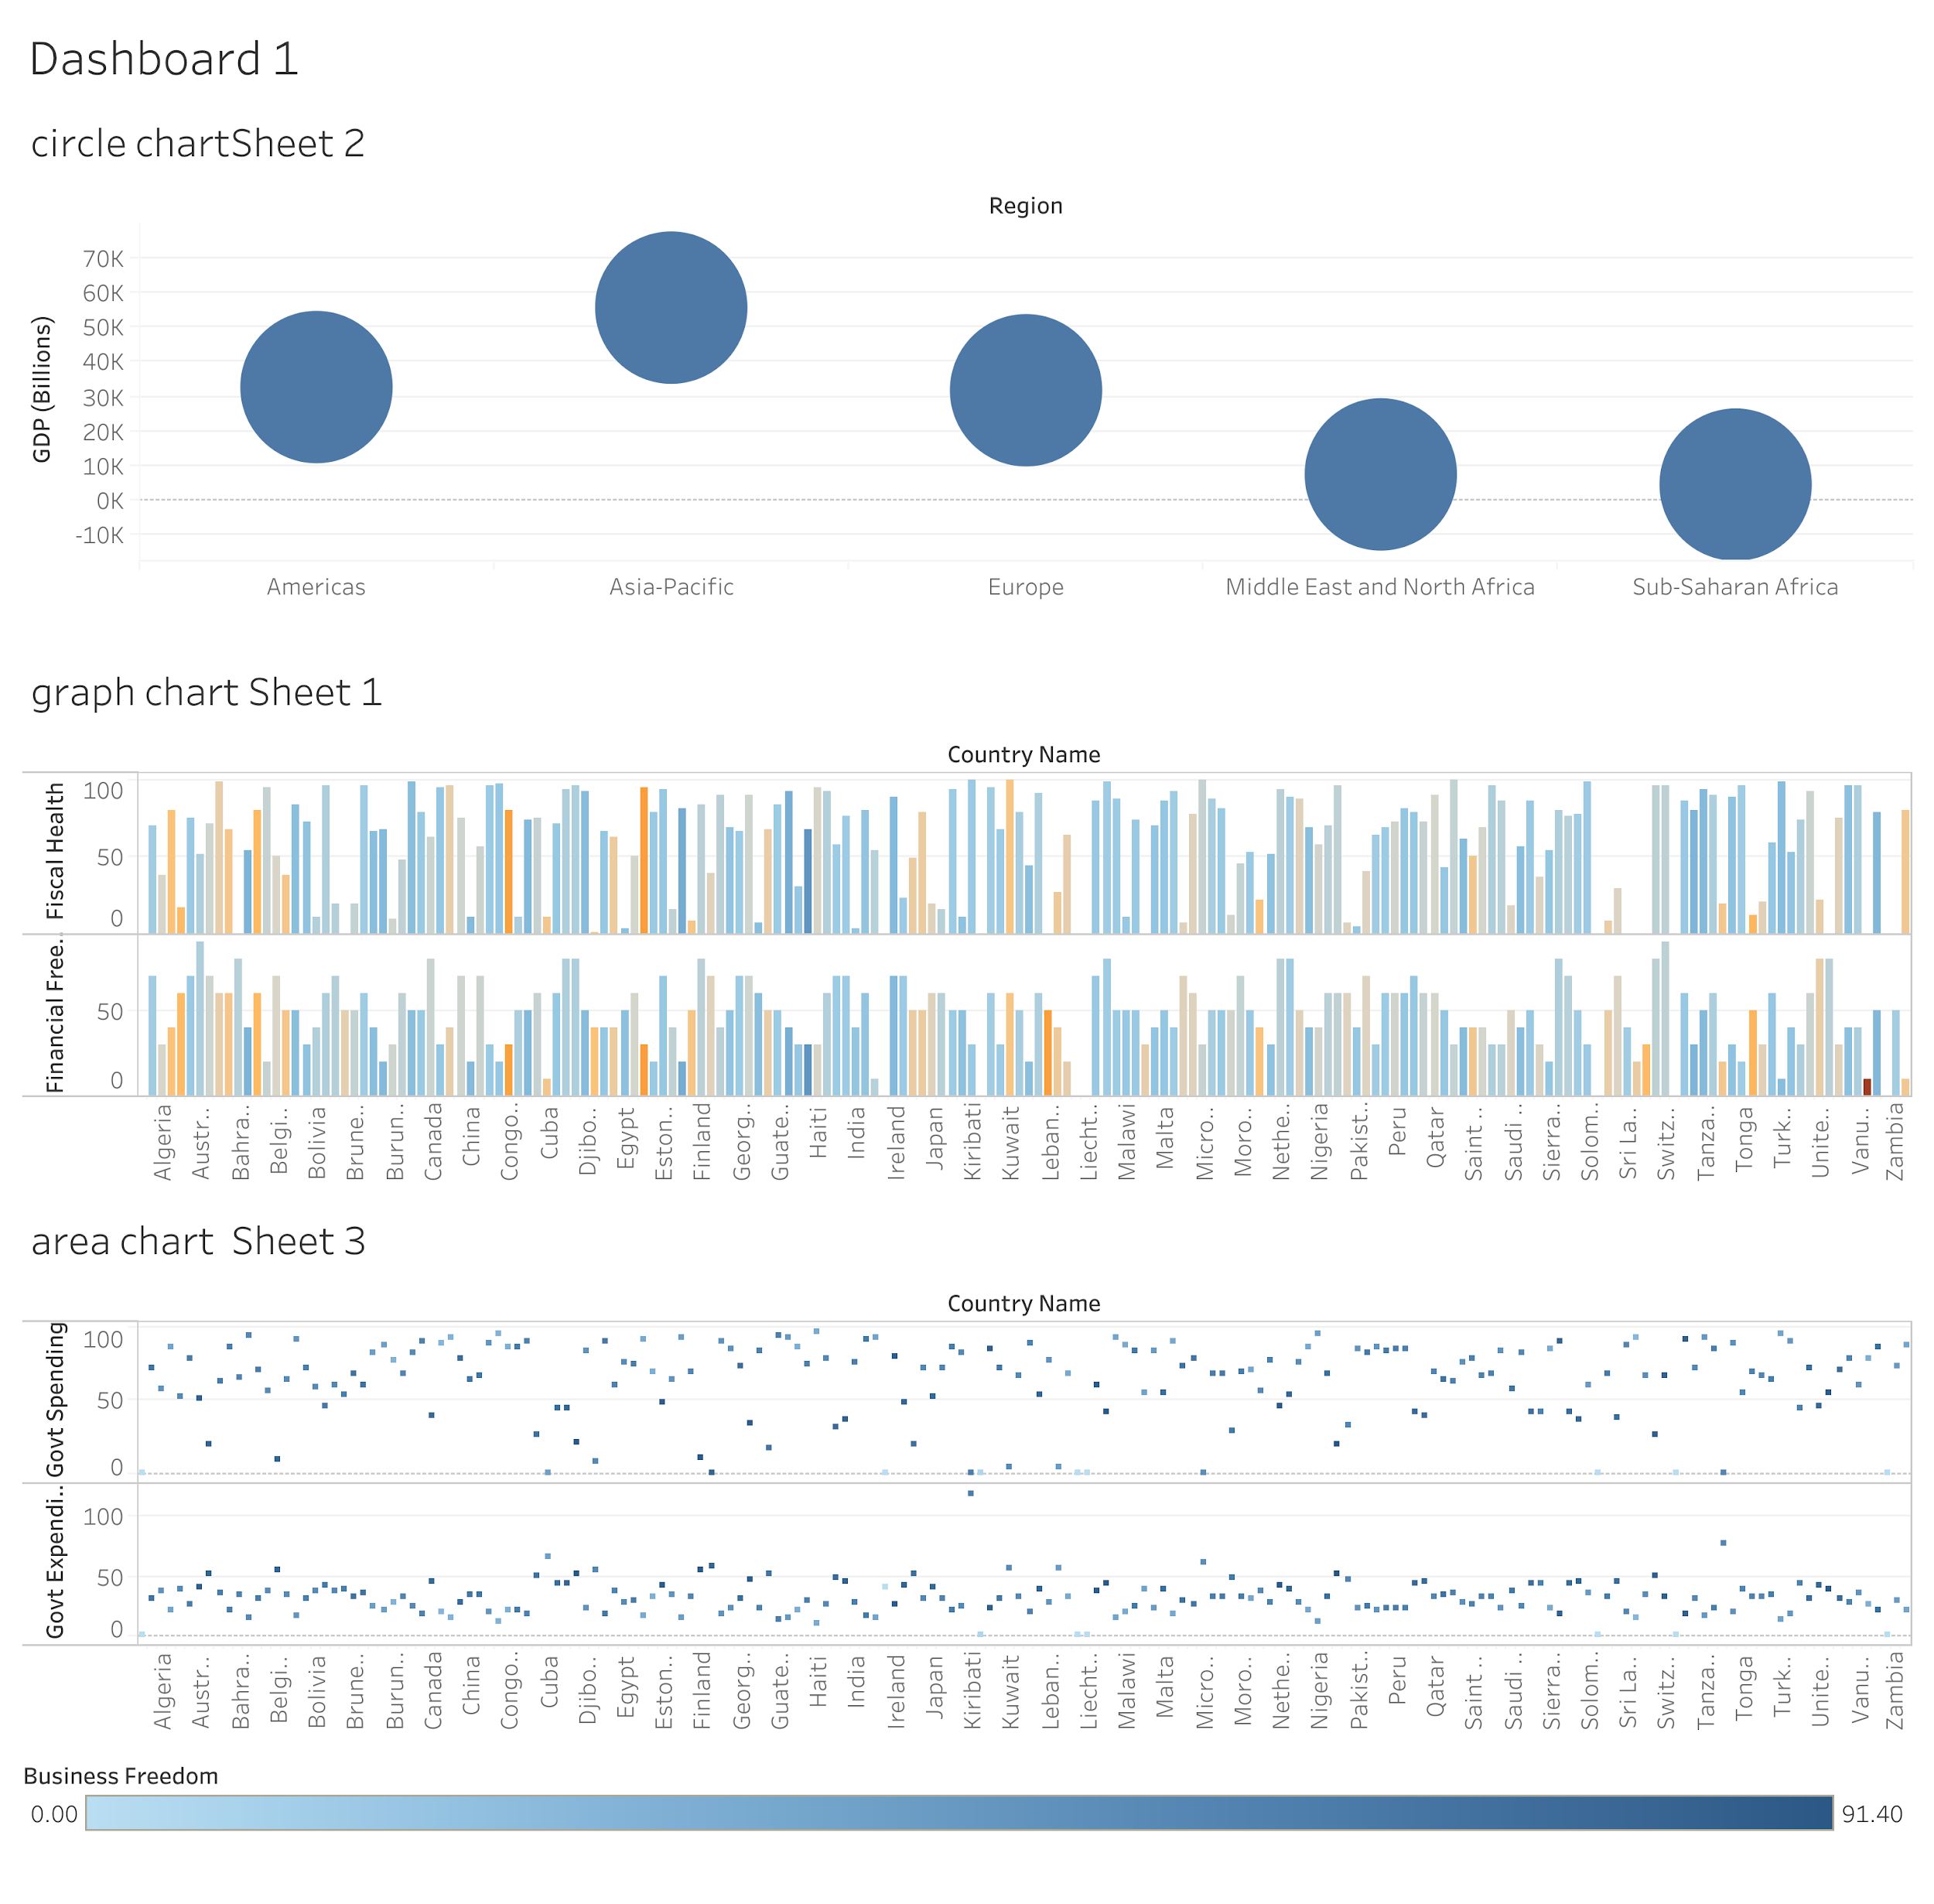

ADVANTAGES OF ECONOMIC PROSPERITY:

1. Technological Improvement – The increased adoption of sophisticated technology leads to efficient and cost-effective production. Furthermore, businesses can produce greater output with the same amount of physical capital.

2. Labor Force – When all other factors remain constant, more workers participate in the productivity of economic goods and services.

3. Human Capital – Providing skilled laborers with training or hiring experienced workers boosts their productivity.

DISADVANTAGES:

1. Demand-pull inflation (if demand increases faster than supply, more people are able to buy more things).

2. Recession usually follows after inflation.

3. Negative externalities (e.g. increase in environmental degradation)An increase in wealth inequality.

FUTURE SCOPE:

After completing your postgraduation in Economics, you can look forward to bagging job roles like Economist, Accountant, Actuary, Financial Consultant, Financial Planner, Risk Analyst, Investment Analyst, Economic Researcher, Economics Teacher/Professor, and much more.

MAIN SCOPE:

The economic scope covers all the central issues faced by society, including economic decline and growth, poverty, unemployment, budgeting, etc. Answer. Economics is regarded as a social science; it studies how people in an economy employ the already scarce resources with or without using money.

CONCLUSION:

Adam Smith made the case that prosperity is produced through a competitive market economy. In such a setting, Smith noted in one of his more famous observations, individuals pursuing their own interests are led as if by an invisible hand to do what is best for the whole society.